IEEE CSS Paper Award Nomination Instructions:
CSS will be using the system based on PaperPlaza for nominations for the following paper awards:
- George S. Axelby Outstanding Paper Award
- TCST Outstanding Paper Award
- TCNS Outstanding Paper Award
- CSM Outstanding Paper Award
- CSL Outstanding Paper Award
- Roberto Tempo Best CDC Paper Award
- Best CCTA Paper Award
Please notice that for the above paper awards supporting letters are not required.
To nominate for a paper award, please follow the steps below:
Ensure yourself is registered users with PaperPlaza. In many cases, you will already have a PaperPlaza login and ID from using CSS conferences or publications. If so, please use your existing ID.
(i) Download the relevant nomination form: (see the relevant pages within https://www.ieeecss.org/awards/award-listing )
(ii) Once you have completed the nomination form, please go to awards.paperplaza.net
(iii) From the awards nomination page, select the ‘Submit a contribution to CSS Awards’ link
(iv) From there, select the appropriate award/nomination by following the submit link in front of “{award name} – Nomination’”
(v) Enter the title of your nomination, then select 1 from the dropdown for the number of proposers and enter your own pin as the proposer (that is nominator) and click on Next

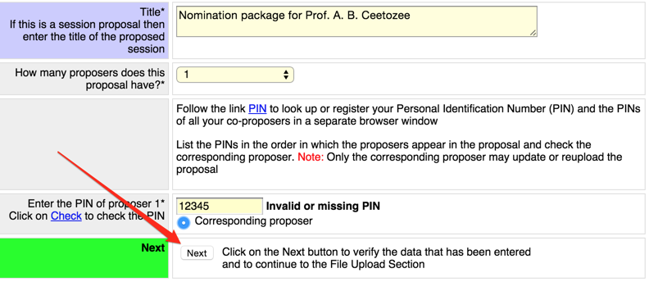
(vi) Attach to the PDF version of the nomination form a PDF copy of the published nominated paper available on the IEEE Xplore website.
(vi) Upload your completed nomination form (note that awards do not need to satisfy PDF compliance checks). The only requirement is that the PDF must not be password protected. Note that the optional supporting information is not required and will not be considered in assessing the nomination.
